Vocab

Vocabulary training for Biblical Hebrew and Aramaic

*Christian Canu Højgaard*

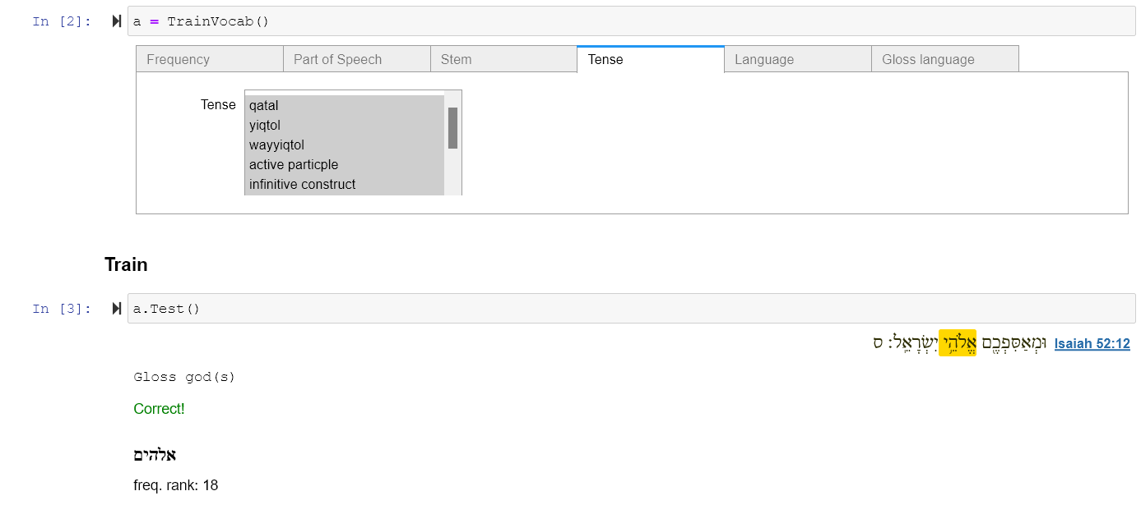

# Introduction

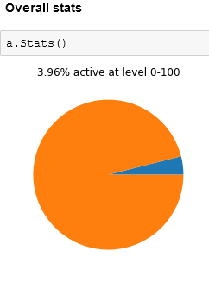This is a training program for practicing Biblical vocabulary (Hebrew and Aramaic). As any language learner will know, vocabulary practicing is an almost endless endeavor. It is the assumption of this program that there is hardly any such thing as “knowing” a lexeme. Rather, a lexeme is either cognitively *active* or *inactive*. An *active* lexeme is defined here as a lexeme that has been practiced relatively recently, with a short response time, and with a low record of mistaken responses. By contrast, an *inactive* lexeme was practiced relatively long time ago, with a long response time, and/or with a high record of mistaken responses. This program essentially applies an algorithm that aims to yield those words which are the most difficult for you and let you practice those instead of those already active in your vocabulary. Another feature of this program is that you are not practicing dictionary forms of the lexemes but those forms that actually exist in the Hebrew Bible. In doing so, you should be well-equipped for reading the real text.

# Installation

To install the vocabulary program, you need first to install a digital environment. This guide will take you step by step (only Windows).

## Install Anaconda

1. Install Anaconda on your computer: <https://www.anaconda.com/products/individual>
2. You should now have a small program installed called Anaconda Prompt

## Install Jupyter

1. Open Anaconda Prompt
2. Type “pip install jupyter” or “pip3 install jupyter”

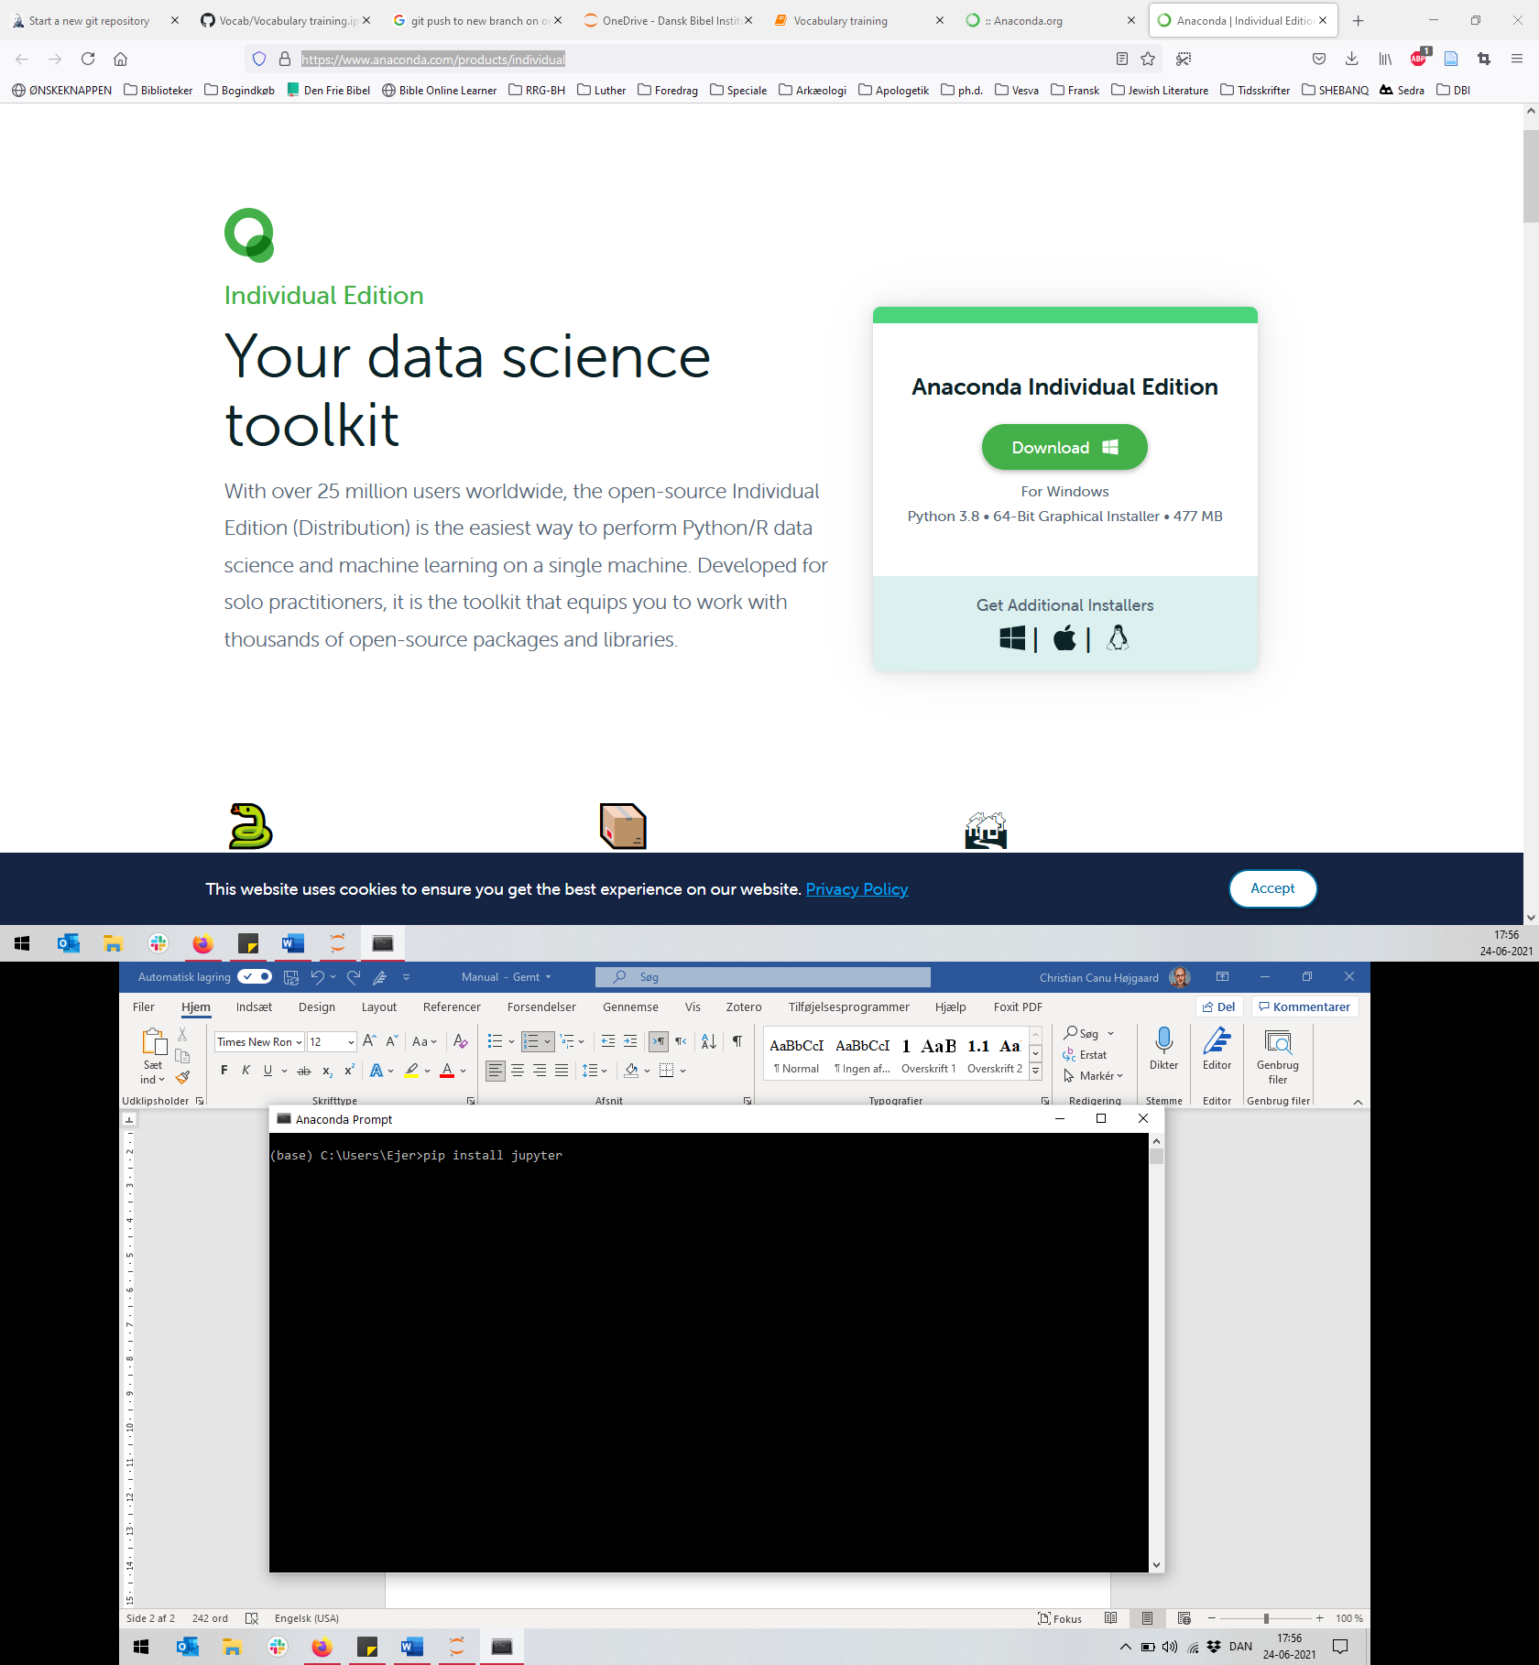

## Install Text-Fabric and other modules

1. Open Anaconda Prompt
2. Type “pip install text-fabric” or “pip3 install text-fabric”
3. Type “pip install ipywidgets” or “pip3 install ipywidgets”
4. Type “text-fabric etcbc/bhsa”

## Download Vocab

1. Go to <https://github.com/ch-jensen/Vocab>
2. Download the repository or click [here](https://github.com/ch-jensen/Vocab/archive/refs/heads/main.zip).
3. Unzip the folder.
4. Store the folder somewhere on your computer (e.g., Documents).
5. If you want to exercise with other glosses than the default English glosses, you need to add the appropriate file with glosses to the same dictionary. For the program to read additional files of glosses, they need to be stored in the same directory as the jupyter notebook and must be labelled [Language]_glosses.csv, e.g., Danish_glosses.csv or German_glosses.csv

## Launch Vocab

1. Open Jupyter Notebook
2. Locate the Vocab-folder stored in step 2.4.
3. Open the file “Vocabulary training.ipynb”

## Use Vocab

1. Jupyter Notebook is a digital environment for running programming scripts. The layout is composed of cells: Cells with text and cells with programming script. Follow the instructions in the Vocab file.
2. To run a cell, press ctrl + enter